Normalizing Load Impedance Zl
Zl = (150 +150j)/50 = 3 +3jΩ

Normalizing Input impedance
Zin = 50/50 = 1 Ω
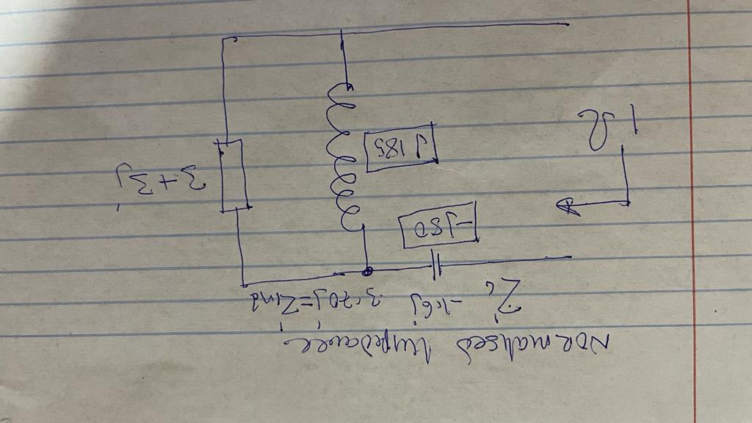

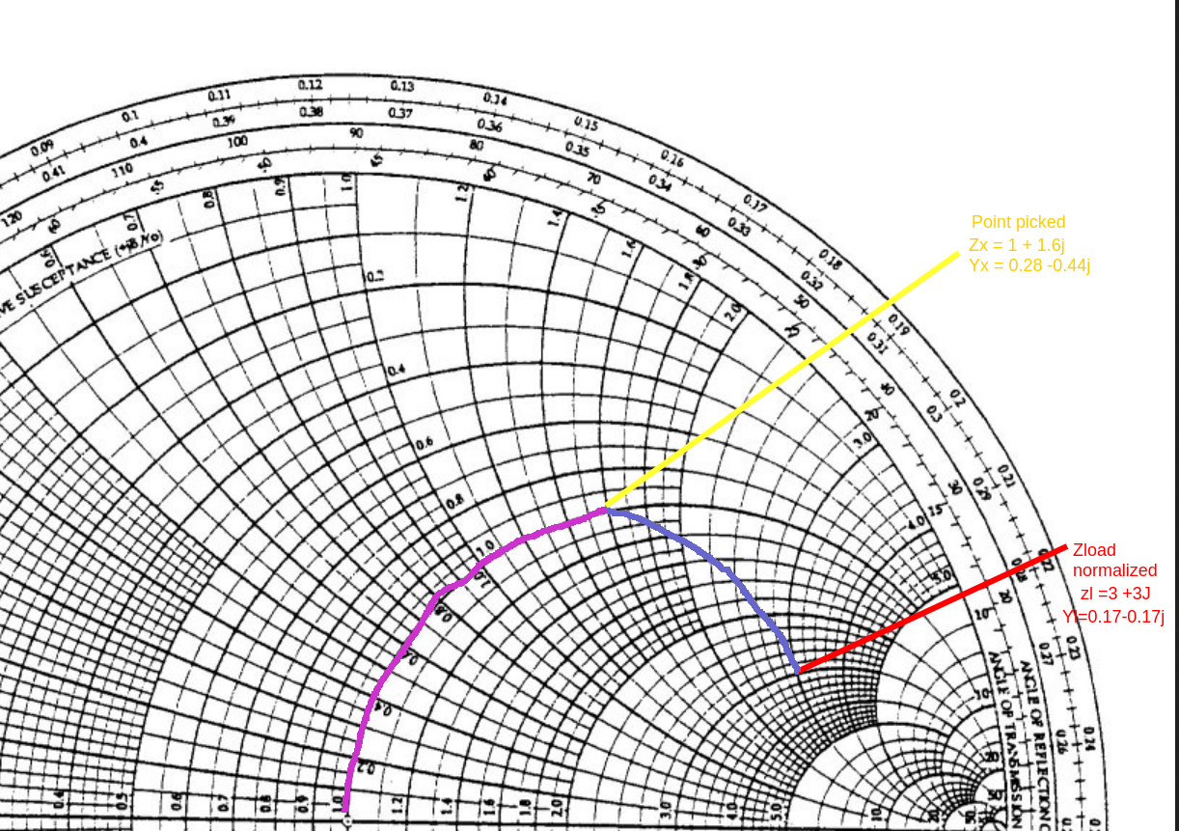
smith chart sketch

Admitance for Zl (Yl )= R/(R^2 + X^2) +j(X/(X^2 + R^2))

= 3/(3^2 + 3^2) + j(3/(3^2 + 3^2))
= 0.166 -j0.166…………………………………………………………..i

Point selected is at Zx = 1 + 1.6j…………………………………………………………………k

Admitance at this point Yx = R/(R^2 + X^2) +j(X/(X^2 + R^2))

= 1/(1+ 1.6^2) + j(1/(1+1.6^2))
= 0.28 – j0.44………………………………………………………..ii

Admittance for the Y_inductance is obtained by getting the difference btn Yl and Yx
for equation I and ii above

Yind = -j0.27
Zind = 1/-0.27 = -j3.7 Ω

Impedance of the capacitor in the Marched network.
From eqn k and 1 ohms

the difference is -j1.6 which is equivalent capacitor impedance Zc

After de-normalizing

Zc = -1.6 *50 = -j80Ω
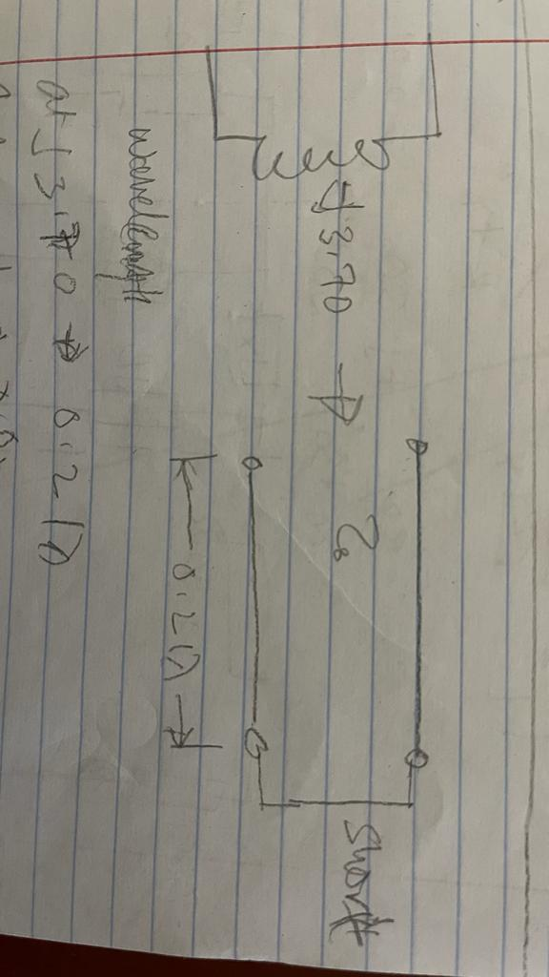
Zind = -3.7 *50 = -j185Ω

Converting inductor into stub line equivalent

reading form the chart for j3.7 is equivalent to 0.21λ

